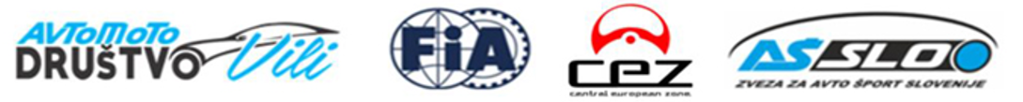
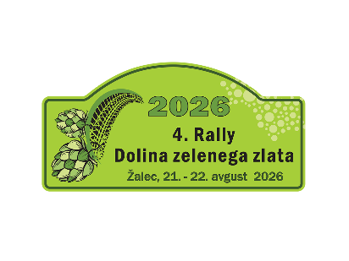
AKREDITACIJSKI OBRAZEC /
ACCREDITATION FORM
MEDIJ / MEDIA:
_________________________________________________________________________________
IME IN PRIIMEK / NAME AND SURNAME:
__________________________________________________________________________________
TEL / PHONE: ___________________________________________________________________
E-MAIL: __________________________________________________________________________
VAŠA VLOGA / YOUR ROLE AT EVENT:
novinar/journalist foto TV

S podpisom se strinjam, da bom na 4. Rally Dolina zelenega zlata sodeloval na lastno odgovornost. V nobenem primeru proti organizatorju, voznikom ali ostalim uradnim osebam, ne bom vlagal odškodninskih zahtevkov.
I am fully aware that I participate at 4th Rally Dolina zelenega zlata at my own responsibility. I will not take any legal charges towards organizer, competitors and other officials.
KRAJ, DATUM / PLACE, DATE PODPIS / SIGNATURE:
Žalec, __________________ ___________________________

Obrazec poslati na naslov / to be sent to: rally@amd-vili.si

